
JOB VACANCY ANNOUNCEMENT
PEACE CORPS - ACCRA

Number: Position: Office: Open to: Work hours:
Closing Date:
Starting salary:

PC 17-006

Volunteer Support Coordinator/Programming (VSC/P)

- S. Peace Corps

All Interested Candidates 40+ a week
June 30, 2017 – 5:00 p.m

38,571GHANA CEDI (plus benefits)

March 23, 2017

PERSONAL SERVICES CONTRACTOR (PSC)
The Peace Corps is a United States federal agency that promotes world peace and friendship by providing trained men and women, Peace Corps Volunteers (PCVs), to serve in countries that have requested assistance. In Ghana, Volunteers serve in local communities in the areas of health, education and agriculture.

The agency is seeking to hire the services of a highly motivated and experienced individual for the Volunteer Support Coordinator-Programming (VSC/P) position to provide programmatic knowledge management support for all the Volunteers in the field. The candidate must have exceptional organizational skills, good interpersonal skills and must be able to multi-process and work under pressure. In addition, the incumbent must have demonstrated advance proficiency in Microsoft Office 2007 and 2010.

This is a permanent, full-time position based at our main office in Accra and reports to the Director of Programming and Training (DPT).

Desired Qualifications and Statement of Work:
  - Please see the attached Desired Qualifications/Requirements and, the Statement of Work.

Qualified applicants must submit the following or the application will not be considered:

- A detailed résumé or C.V. stating your experience, skills and qualifications that includes 3 professional references.

- A cover letter

- Any other documentation (e.g., certificates, awards, copies of degrees earned) that addresses the qualification requirements of the position as listed above.

Write the job number and position title as email subject and submit the application packet electronically to jobs@gh.peacecorps.gov or by mail to US Peace Corps, PO Box 5796,Accra North, Accra, Ghana

All experience, skills and qualifications will be verified. In addition, employment is contingent on a favorable security background check.

U.S. Peace Corps – Ghana
Volunteer Support Coordinator/Programming (VSC/P)
Number of Positions: 1
Duty Station: Accra, Ghana

REQUIRED QUALIFICATIONS

  - Bachelor Degree in community development, Business or related fields
  - Excellent IT skills using: MS Word, Outlook, Excel, Power Point, Publisher
  - Experience organizing large amounts of paper and data.
  - Good administrative skills
  - Experience working in a cross-cultural setting/environment
  - Knowledge and understanding of US values, history, and culture
  - Willingness to work hard, long hours.
  - Ability to learn complex systems and subjects quickly.
  - Excellent speaking, writing, presentation, and all-round communication skills
  - Excellent spoken and written English
  - Proven ability to work independently with minimal supervision and minimal review of work; taking initiative and being able to develop solutions for complex issues is key

DESIRED QUALIFICATIONS
  - US work experience or overseas travel
  - Experience working with the U.S. Peace Corps or similar international development organization
  - Basic budgeting experience
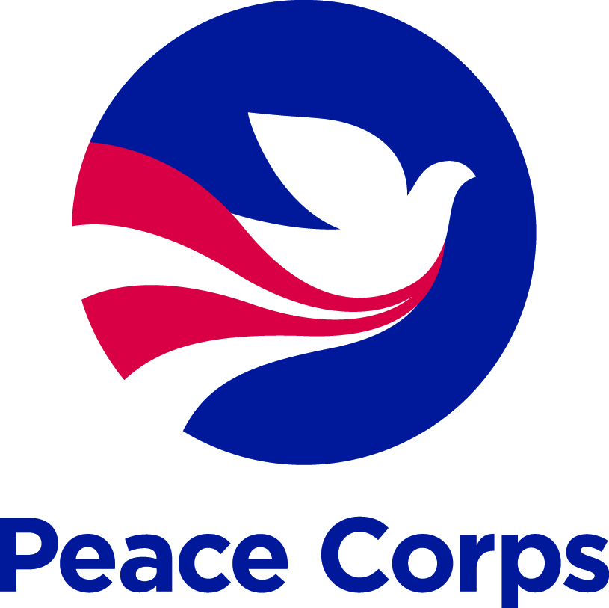
U.S. PEACE CORPS GHANA

STATEMENT OF WORK:
Volunteer Support Coordinator/Programming (VSC/P)

POSITION DESCRIPTION

The U.S. Peace Corps is an agency that promotes world peace and friendship by providing trained men and women, Peace Corps Volunteers (PCVs), to serve in countries that have requested assistance. In PC-Ghana, the Volunteer Support Coordinator for Programming (VSC/P) will provide programmatic knowledge management support for all PCVs in the field. Through the promotion of best practices, partnership development and maintenance, and sharing of useful site information, the VSC/P will enable more PCVs to engage in significantly more meaningful work opportunities during their tenure in their host communities. The VSC/P will work hand-in-hand with the Director of Programming and Training (DPT), Associate Peace Corps Directors (APCDs) and Coordinators to identify PCVs in need of additional programmatic guidance and support and will reach out to those PCVs to encourage them to engage in projects with a proven track record for success. Volunteer Support is, by definition, proactive and the incumbent will be expected to be among the most active staff members in reaching out to PCVs and building relationships based on trust, efficiency and productivity. The VSC/P will serve as the cross-sector institutional memory for Peace Corps Ghana and will be expected to collaborate with PCVs to produce materials that promote the sharing of programmatic success stories, best practices and lessons learned which can then be replicated by future generations of PCVs.

- Knowledge Management 40%
- Volunteer Outreach 25%
- Partnership Outreach and Coordination 30%
- Training 5%

MAJOR DUTIES AND RESPONSIBILITIES

- Knowledge Management – 40%
  - Use desktop publishing software to develop high quality, professional, useful Site Announcement booklets for each new and replacement site developed at Peace Corps Ghana in all sectors.
  - Research the site history files and VRT information of each potential PCV site, with an eye towards sharing useful programmatic information with new PCVs assigned to that site.
  - Research development work being done outside of Peace Corps at each potential site in order to promote awareness of meaningful work opportunities amongst new PCVs.
  - Coordinate the community data gathering efforts by current PCVs who are going to be replaced so that the information can be fed into the Site Announcement booklets.
  - Create an effective community of practice with key program managers, PCVLs and OPATS staff outside of Ghana that can assist in the broadcasting of PCV project-level success stories, lessons learned documents and best practices that can be replicable by PCVs in Ghana.
  - Liaise with the DPT, APCDs and Coordinators to keep abreast on the activities being conducted in Ghana at the host community level.
  - Utilize social media platforms to promote best practices amongst the current PCV Ghana community.
  - Liaise with programmatic committees to ensure that best practices are being promoted to the general PCV audience.
  - Create Invitee and Site Profile binders for CD, DPT and APCDs which organize incoming trainees invitee questionnaires, resumes, aspiration statements and site profiles for each incoming training group.

- Volunteer Outreach 25%
- Work with the DPT, APCDs and Coordinators to identify PCVs in need of programmatic guidance and support.
- Initiate dialogue with PCVs to go into detail about their programmatic challenges at site, troubleshooting solutions with them on ways to navigate the challenges.
- Use VIDA to track all relevant discussions with PCVs so that P&T staff members can be kept abreast of the VSC/P’s activities.
- Liaise with PCVs to identify potential partners in the field with whom we have overlapping goals and objectives.
- Manage Volunteer Exchange Mentoring program requests on behalf of the P&T staff to ensure that the exchanges are meaningful training and collaborative opportunities.
- Identify trends that serve as roadblocks to programmatic performance of PCVs.
- Advocate with senior management on issues that have relevance in impeding overall programmatic performance of the PCVs.
- Troubleshoot collaborative opportunities between PCVs and partners to ensure that expectations of all sides of the arrangement (PCV, partner, PC Ghana, GOG) are being met.

- Partnership Outreach and Coordination 30%
  - Promote Peace Corps Ghana as a valuable resource for international development partners looking for grass-roots level information and support for their projects.
  - Assist the DPT in developing an outreach campaign to relevant partners with whom we have overlapping goals and objectives.
  - Participate in exploratory meetings with current and potential partners, representing the collaboration from the PCVs’ perspective in the field.
  - Manage the contact information of all active and potential partners of PC Ghana.
  - Create an RPCV database for COS conference participation and other events needing RPCV support.
  - Work with PCVs in the field to encourage them to experiment on collaborative opportunities with other development organizations sharing a geographic implementation zone with our PCVs.
  - Serve as the point person on staff with our ‘plug-and-play’ initiatives such as Grassroots Soccer, Village Bicycle Project, STOMP Malaria, and the Rotary Tema / Brother’s Brother Foundation school library projects, amongst many others.

- Training and Miscellaneous 5%
  - Participate in occasional IST events as a means of providing useful programmatic information on success stories, lessons learned and best practices that can be scaled up through the replication of efforts of other PCVs.
  - Promote collaboration and partnership opportunities amongst the PCV population at training events, providing sufficient detail so that PCVs can buy into the mission and assume ownership for the collaborative opportunities to make it their own.
  - Assist the DPT and APCDs during initial trainee interviews
  - Respond timely to additional assignments from the DPT and CD.

This position may act as an Occasional Money Handler, as assigned, to perform work within the scope of duties. The PSC may be required to courier cash and/or purchase orders to various vendors who furnish supplies and/or services to PST/IST training sites, or other locations as directed by the Contracting Officer. The PSC may also be required to courier cash to PC trainees or volunteers. The PSC will not be functioning as a procurement or disbursing official but will only be acting as an intermediary between the Contracting or Disbursing Officer and the recipient. In the case of dealing with vendors, the PSC will not exercise any procurement discretion concerning the supplies or services to be purchased or the cost limits of these purchases; these will be determined by the Contracting Officer;
of the Peace Corps Act.

OPR: SS/OO and Global Operations

Safety and Security Duties for all Peace Corps positions:
- Addresses safety and security proactively by ensuring appropriate assignments for Volunteers and adhering to Peace Corps site development policies and procedures.
- Identifies and immediately communicates Volunteer safety and security concerns or issues to the Safety and Security Manager (SSM) and the CD.
- Ensures prospective sites meet established programmatic and safety/security criteria (e.g., safe housing, a clearly defined assignment with an organization that shows real interest in working with a Volunteer, etc.).
- Reviews and references site history files when evaluating potential sites. Incorporates appropriate site-specific safety and security-related information into site history files.
- Ensures designated host country counterparts participate in counterpart orientation/training and are prepared to work with and support Volunteers, including their role in Volunteer safety and security.
- Maintains communication with each Volunteer and solicits periodic feedback, including information about Volunteer safety and security.
- Maintains a calendar of Volunteer site visits, and completes appropriate number of site visits to assess Volunteer progress, safety and security, and to provide technical guidance and moral support.
- Monitors Volunteer compliance with Peace Corps policies, especially related to safety and security, and initiates corrective action as necessary.
- Participates in the design and implementation of the Emergency Action Plan (EAP).
- Acts as duty officer, as needed.
- Knowledgeable and supportive of Peace Corps safety and security policies and procedures, including the timely reporting of suspicious incidents, persons or articles.

Temporary Duties (TDY):
The contractor is subject to worldwide availability and may be requested by the Peace Corps to be reassigned or transferred permanently to another Peace Corps Post/Headquarters or perform temporary duties (TDY) as required and to travel to other assignments within Peace Corps’ as assigned.
Any such reassignment or transfer shall be subject to agreement of the Contractor. The Statement of Work as defined will remain the same: however the duties may be subject to change as determined by the Contracting Officer.

Level of Effort:
Performs duties during a 40 hour work week. Regular work hours for Peace Corps Ghana are 0730 – 1700 Monday through Thursday, and 0730 – 1230 Fridays. Staff may be required to work longer hours, weekends, or holidays according to the needs of the program. Work is normally performed in an office setting. Occasional travel outside of the office may be required.

